Board Game Book Project
For the second trimester, your child will be asked to read a book at home. The book may be any genre except non-fiction. I ask that the book be at least 100 pages in length. They will then design and construct their own board game based on the characters, setting, and problem in the book. This game can have (but is not limited to) a design similar to already existing games (Sorry, Monopoly, Chutes and Ladders, Battleship, Candyland, or Trivial Pursuit). The game must also include clear rules as it will be played by other classmates. There will not be a class presentation or written summary. The project is due Friday, February 27th.
Directions:
- Read a book at home (100 pages in length)
- Design a board game that includes:
  - 8 of the important events that happen in the book. These could be squares on the board, cards that players draw, or included in some other form.
  - At least four (4) of the characters from the book. This could be as the game pieces that players use (identified by color in the rules) or in some other form.
  - The main setting as a backdrop to the game, as individual squares, or in some other form.
  - The problem in the book is reflected in the game. It could be that the object of the game is the same as solving the problem in the story.
- Make the game board neat and colorful.
- Create/design all of the extra parts for the game (cards, spinners, dice, game pieces, etc.).
- Include a very clear and detailed set of rules on the back of the board.
- Bring the board, rules, game pieces, and game cards to school on Friday, February 27th to play it with friends.
Due Dates:
- Book Selected – Thursday, February 5th (students have been given time to select a book from my library)
- Read ½ of book and complete Problem/Characters/Setting Graphic Organizer – Friday, February 13th
- Finish book and complete Important Events Graphic Organizer – Friday, February 20th
- Rough Draft of Game Board – Monday, February 23rd
- Completed Game Board and Rules – Friday, February 27th

_ _ _ _ _ _ _ _ _ _ _ _ _ _ _ _ _ _ _ _ _ _ _ _ _ _ _ _ _ _ _ _ _ _ _ _ _ _ _ _ _ _ _ _ _ _ _ _ _ _ _ _ _ _ _ _ _ _ _ _ _

Name of Student: _____________________ Title of Book: _______________________________________
Parent Signature: _____________________________________ Please sign and return by Thursday, Feb. 5th

Rubric (How to get an A)
 | 10 points | 8 points | 6 points | 4 points
The Game  (important elements: characters, setting, the problem) | The game includes all of the important elements from the book. | The game includes many of the important elements of the book. | The game includes some of the important elements of the book. | The game includes none of the important elements of the book.
Important Events | Eight (8) important events from the book are incorporated into the game. | Six (6) important events from the book are incorporated into the game. | Four (4) important events from the book are incorporated into the game. | Two (2) important events from the book are incorporated into the game.
The Rules | The rules are clear and detailed. I can play the game without the creator there to explain it. | The rules are fairly easy to understand with only a few unclear directions. | The rules are difficult to understand. | The rules are impossible to understand.
The Board | The board is made with neat handwriting and is very colorful. | The board is colorful but lacks neatness.  –or-  The board is neat but lacks color. | The board is bland and lacks neatness. | The board lacks color and neatness. The writing is very difficult to read.
The Book  (important elements include the problem AND solution) | Student is able to explain all the important elements of the story to me. | Student is able to explain many of the important elements to me. | Student is able to explain some of the important elements to me. | Student is able to explain few of the important elements to me.
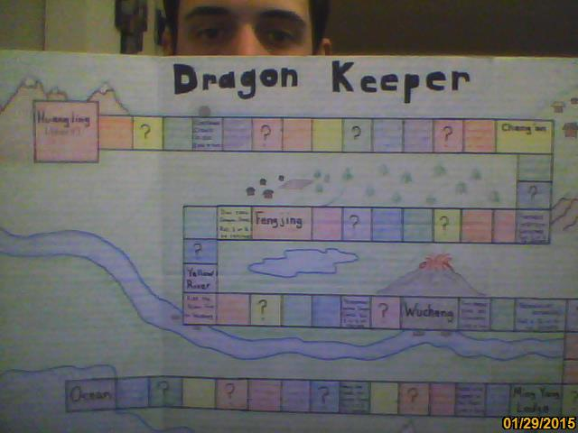
Example:

Please be as creative as possible with this project! Your board game does not have to look anything like the one above!

